TASK 1
RECORD – 5 Progressive Problems

Record – Problem 1: Immutable Student Snapshot
record StudentRecord(String name, int rollNo, int marks) {
public void printSummary() {
System.out.println("Student Name : " + name);
System.out.println("Roll Number : " + rollNo);
System.out.println("Marks : " + marks);
}
public static void main(String[] args) {
StudentRecord s = new StudentRecord("Nandhy", 101, 90);
s.printSummary();
System.out.println(s.name() + " (Roll No: " + s.rollNo() + ") scored " + s.marks());
}
}

Output:
Student Name : Nandhy
Roll Number : 101
Marks : 90
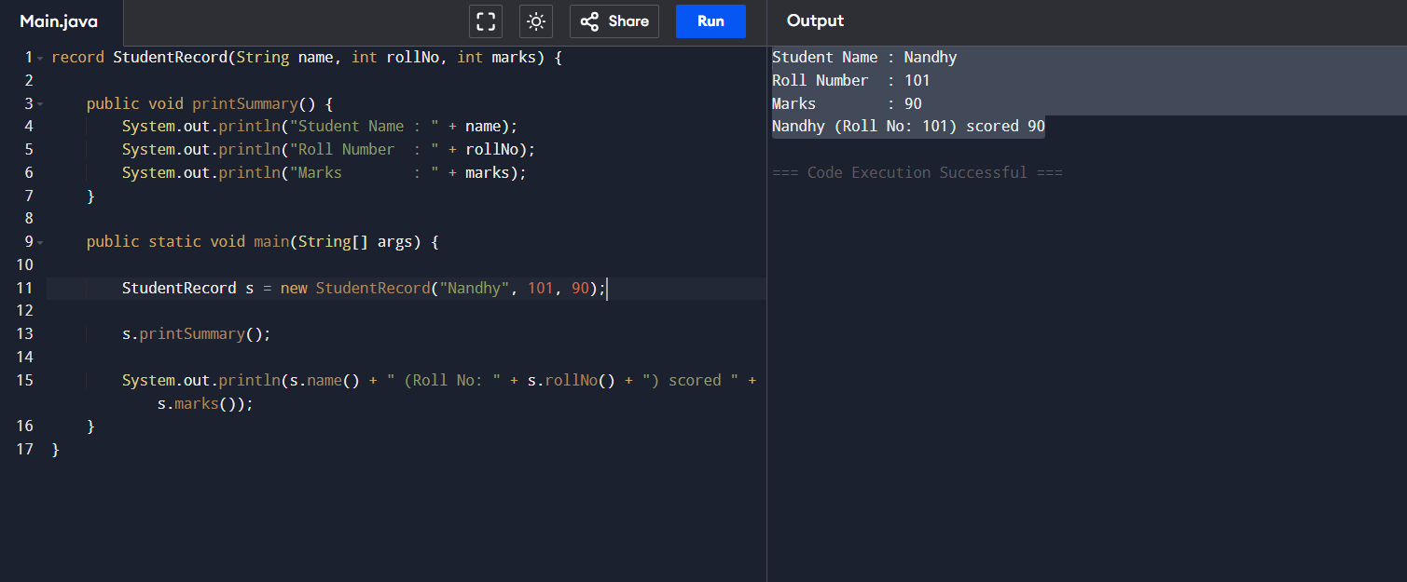
Nandhy (Roll No: 101) scored 90

Record – Problem 2: Derived Data Inside Record
record StudentRecord(String name, int rollNo, int marks) {
public String grade() {
if (marks >= 90)
return "A";
else if (marks >= 75)
return "B";
else if (marks >= 60)
return "C";
else if (marks >= 50)
return "D";
else
return "F";
}
public void printSummary() {
System.out.println("Student Name : " + name);
System.out.println("Roll Number : " + rollNo);
System.out.println("Marks : " + marks);
System.out.println("Grade : " + grade());
}
public static void main(String[] args) {
StudentRecord s = new StudentRecord("Nandhy", 101, 88);
s.printSummary();
}
}
Output:
Student Name : Nandhy
Roll Number : 101
Marks : 88
Grade : B
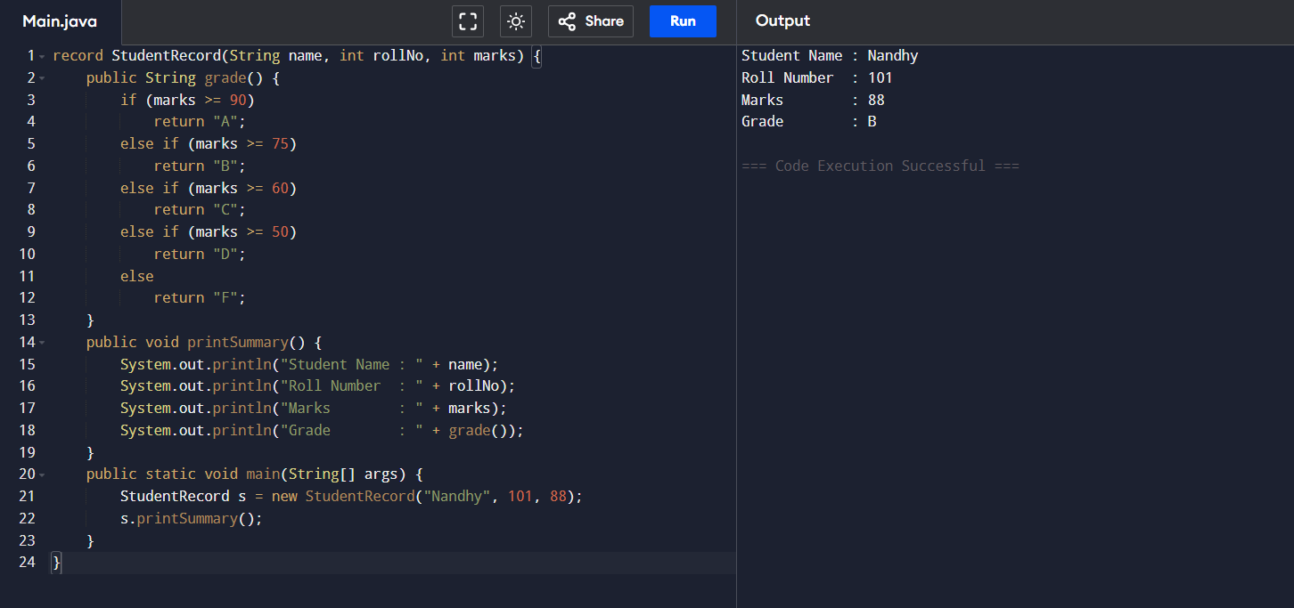

Record – Problem 3: Validation in Canonical Constructor

public class Main {
public static void main(String[] args) {

try {
TransactionRecord t1 = new TransactionRecord(1500.5, "USD");
System.out.println("Transaction Created:");
System.out.println("Amount: " + t1.amount());
System.out.println("Currency: " + t1.currency());

TransactionRecord t2 = new TransactionRecord(-200, null);

} catch (IllegalArgumentException e) {
System.out.println("Invalid Transaction: " + e.getMessage());
}
}
}

record TransactionRecord(double amount, String currency) {

public TransactionRecord {
if (amount <= 0) {
throw new IllegalArgumentException("Amount must be greater than 0");
}

if (currency == null) {
throw new IllegalArgumentException("Currency cannot be null");
}
}
}
Output:
Transaction Created:
Amount: 1500.5
Currency: USD
Invalid Transaction: Amount must be greater than 0

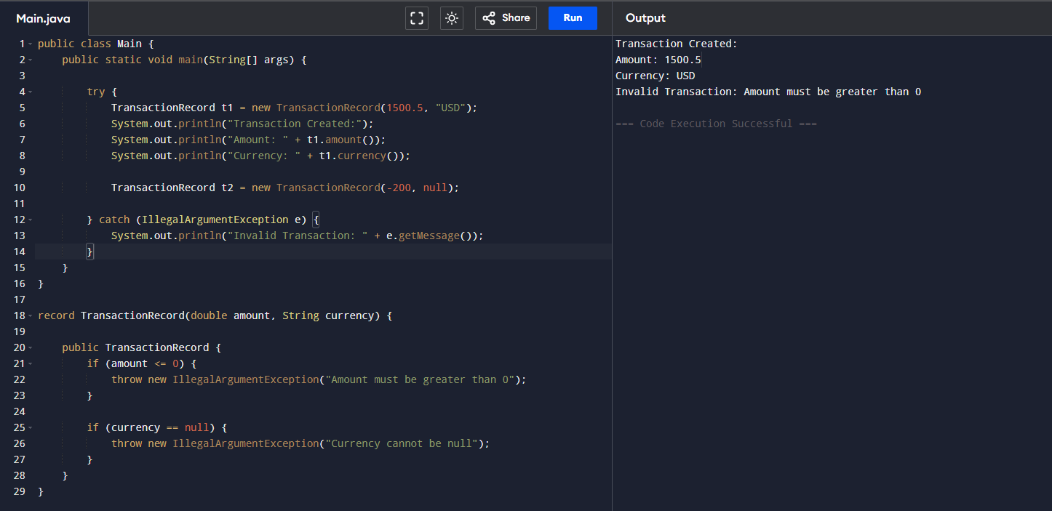

Record – Problem 4: Nested Record Modeling
public class Main {
public static void main(String[] args) {

OrderRecord.Customer customer =
new OrderRecord.Customer(101, "Nandhini");

OrderRecord.Address address =
new OrderRecord.Address("12 Gandhi Street", "Chennai", "600001");
OrderRecord order = new OrderRecord(5001, customer, address);
System.out.println("Order ID: " + order.orderId());
System.out.println("Customer ID: " + order.customer().customerId());
System.out.println("Customer Name: " + order.customer().name());
System.out.println("City: " + order.address().city());
System.out.println("Pincode: " + order.address().pincode());
}
}
record OrderRecord(int orderId, Customer customer, Address address) {

record Customer(int customerId, String name) {}

record Address(String street, String city, String pincode) {}
}

Output:
Order ID: 5001
Customer ID: 101
Customer Name: Nandhini
City: Chennai
Pincode: 600001
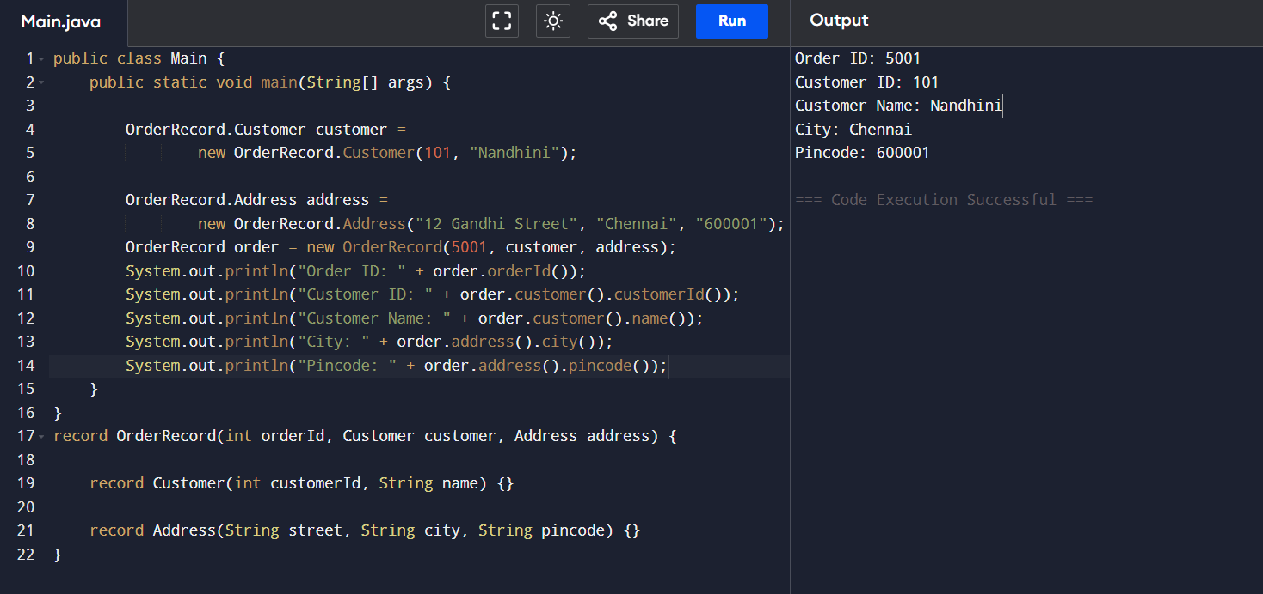

Record – Problem 5: Behaviour + Domain Rule
public class Main {
public static void main(String[] args) {

EmployeePayrollRecord emp = new EmployeePayrollRecord(50000, 5000, 10);
System.out.println("Base Salary: " + emp.baseSalary());
System.out.println("Allowance: " + emp.allowance());
System.out.println("Tax %: " + emp.taxPercent());
System.out.println("Net Salary: " + emp.netSalary());
}
}

record EmployeePayrollRecord(double baseSalary, double allowance, double taxPercent) {
public double netSalary() {
double gross = baseSalary + allowance;
double taxAmount = gross * taxPercent / 100;
return gross - taxAmount;
}
}
Output:
Base Salary: 50000.0
Allowance: 5000.0
Tax %: 10.0
Net Salary: 49500.0
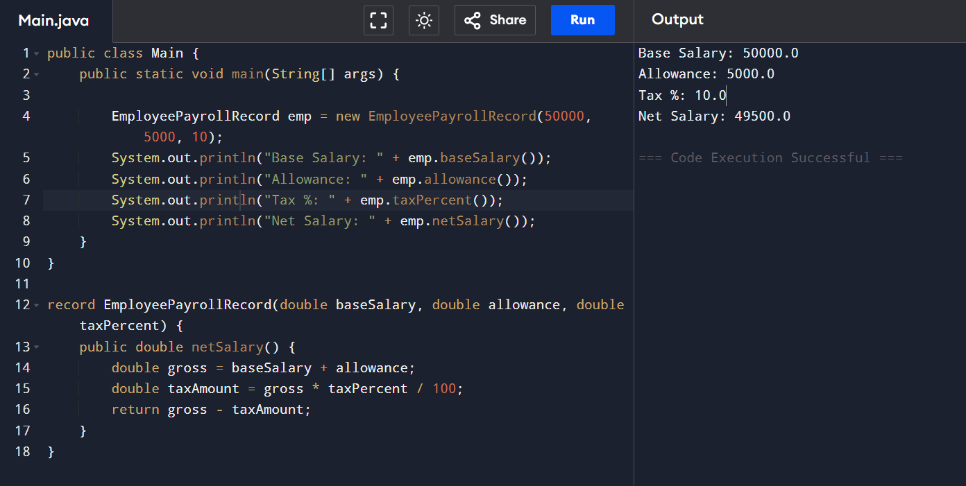

SEALED – 5 Progressive Problems

Sealed – Problem 1: Restricted Vehicle Types
public class Main {
public static void main(String[] args) {
Vehicle v1 = new Car();
Vehicle v2 = new Bike();
Vehicle v3 = new Truck();
v1.showType();
v2.showType();
v3.showType();
}
}
sealed class Vehicle permits Car, Bike, Truck {
void showType() {
System.out.println("This is a vehicle.");
}
}
final class Car extends Vehicle {
@Override
void showType() {
System.out.println("Car is a vehicle.");
}
}
final class Bike extends Vehicle {
@Override
void showType() {
System.out.println("Bike is a vehicle.");
}
}
final class Truck extends Vehicle {
@Override
void showType() {
System.out.println("Truck is a vehicle.");
}
}
Output:
Car is a vehicle.
Bike is a vehicle.
Truck is a vehicle.
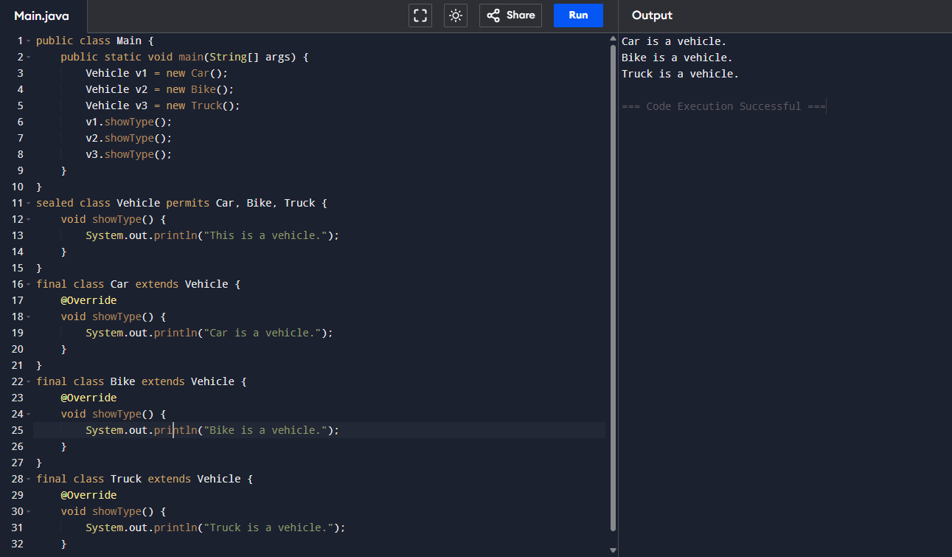

Sealed – Problem 2: Behaviour Enforcement
public class Main {
public static void main(String[] args) {
Vehicle v1 = new Car();
Vehicle v2 = new Bike();
Vehicle v3 = new Truck();
System.out.println("Car Max Speed: " + v1.maxSpeed() + " km/h");
System.out.println("Bike Max Speed: " + v2.maxSpeed() + " km/h");
System.out.println("Truck Max Speed: " + v3.maxSpeed() + " km/h");
}
}
sealed abstract class Vehicle permits Car, Bike, Truck {
abstract int maxSpeed();
}
final class Car extends Vehicle {
@Override
int maxSpeed() {
return 180;
}
}
final class Bike extends Vehicle {
@Override
int maxSpeed() {
return 120;
}
}
final class Truck extends Vehicle {
@Override
int maxSpeed() {
return 90;
}
}
Output:
Car Max Speed: 180 km/h
Bike Max Speed: 120 km/h
Truck Max Speed: 90 km/h
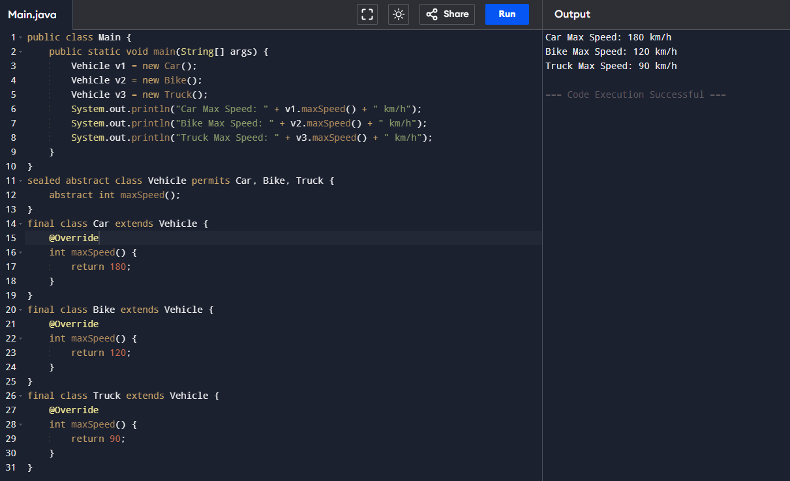

Sealed – Problem 3: Mixed Hierarchy

public class Main {
public static void main(String[] args) {
Vehicle v1 = new Car();
Vehicle v2 = new Truck();
Vehicle v3 = new HeavyTruck();
v1.showType();
v2.showType();
v3.showType();
}
}
sealed class Vehicle permits Car, Truck {
void showType() {
System.out.println("This is a vehicle.");
}
}
final class Car extends Vehicle {
@Override
void showType() {
System.out.println("Car vehicle");
}
}
non-sealed class Truck extends Vehicle {
@Override
void showType() {
System.out.println("Truck vehicle");
}
}
class HeavyTruck extends Truck {
@Override
void showType() {
System.out.println("Heavy Truck vehicle");
}
}
Output:
Car vehicle
Truck vehicle
Heavy Truck vehicle
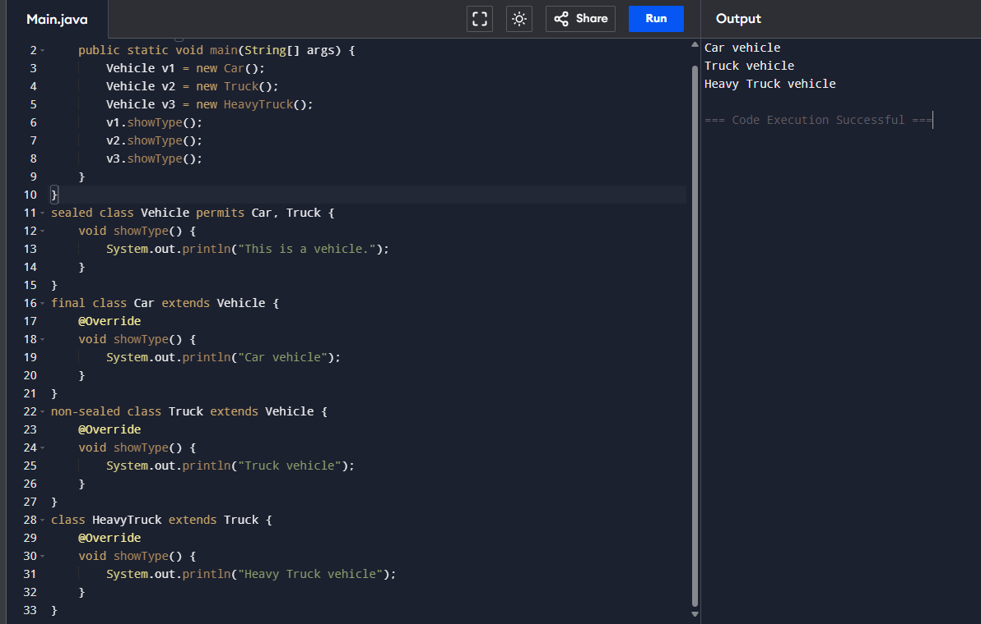

Sealed – Problem 4: Controlled Extensibility
public class Main {
public static void main(String[] args) {

Payment p1 = new CreditCard();
Payment p2 = new DebitCard();
Payment p3 = new UPI();

p1.pay();
p2.pay();
p3.pay();
}
}

// Sealed parent class
sealed abstract class Payment permits CreditCard, DebitCard, UPI {
abstract void pay();
}

// Allowed subclasses (extendable internally)
non-sealed class CreditCard extends Payment {
@Override
void pay() {
System.out.println("Payment using Credit Card");
}
}

non-sealed class DebitCard extends Payment {
@Override
void pay() {
System.out.println("Payment using Debit Card");
}
}

non-sealed class UPI extends Payment {
@Override
void pay() {
System.out.println("Payment using UPI");
}
}
Output:
Payment using Credit Card
Payment using Debit Card
Payment using UPI
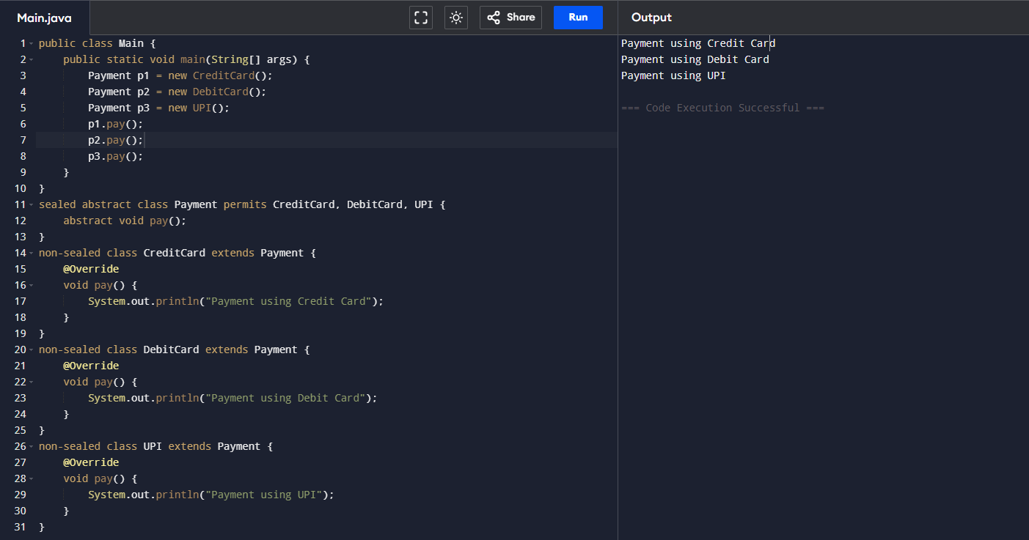

Sealed – Problem 5: Compliance Model
public class Main {
public static void main(String[] args) {
InsurancePolicy p1 = new Health();
InsurancePolicy p2 = new Life();
InsurancePolicy p3 = new Vehicle();
p1.policyType();
p2.policyType();
p3.policyType();
}
}
sealed abstract class InsurancePolicy permits Health, Life, Vehicle {
abstract void policyType();
}

final class Health extends InsurancePolicy {
void policyType() {
System.out.println("Health Insurance Policy");
}
}
final class Life extends InsurancePolicy {
void policyType() {
System.out.println("Life Insurance Policy");
}
}
final class Vehicle extends InsurancePolicy {
void policyType() {
System.out.println("Vehicle Insurance Policy");
}
}
Output:
Health Insurance Policy
Life Insurance Policy
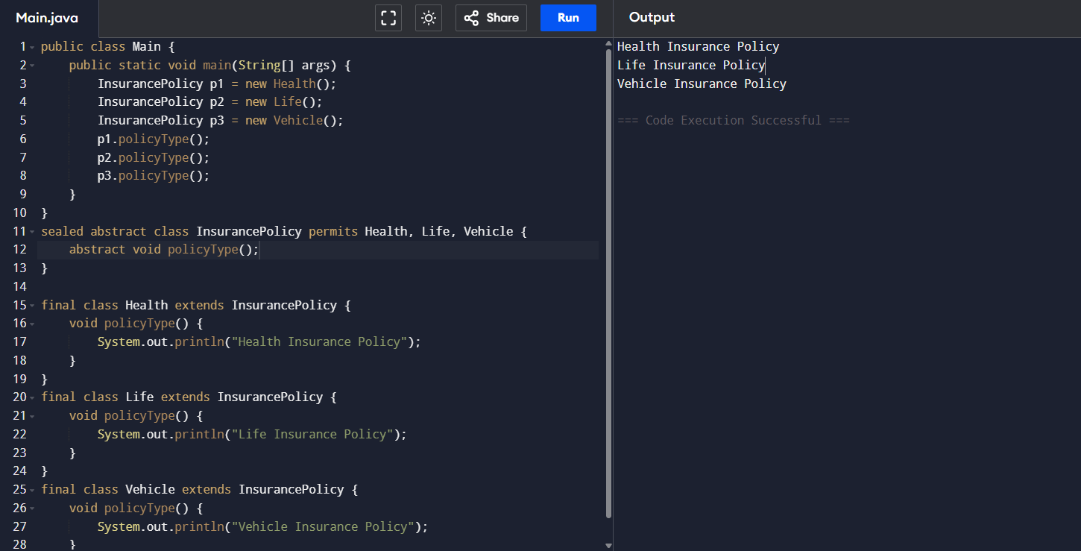
Vehicle Insurance Policy

FACTORY – 5 Progressive Problems
Factory – Problem 1: Notification Creator
public class Main {
public static void main(String[] args) {
Notification n1 = NotificationFactory.createNotification("EMAIL");
Notification n2 = NotificationFactory.createNotification("SMS");
n1.notifyUser();
n2.notifyUser();
}
}
interface Notification {
void notifyUser();
}
class EmailNotification implements Notification {
public void notifyUser() {
System.out.println("Sending Email Notification");
}
}
class SMSNotification implements Notification {
public void notifyUser() {
System.out.println("Sending SMS Notification");
}
}
class NotificationFactory {

public static Notification createNotification(String type) {

if (type.equalsIgnoreCase("EMAIL")) {
return new EmailNotification();
}
else if (type.equalsIgnoreCase("SMS")) {
return new SMSNotification();
}

return null;
}
}
Output:
Sending Email Notification
Sending SMS Notification

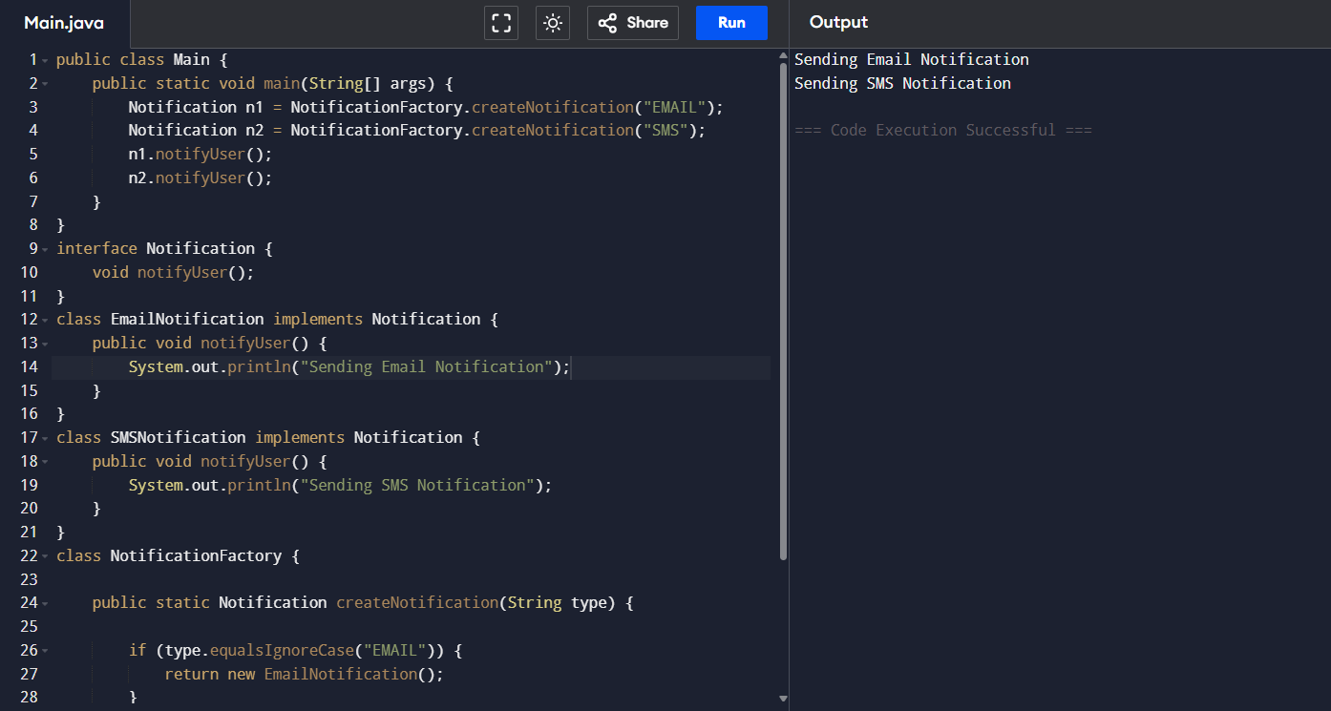

Factory – Problem 2: Parameter-Based Factory
public class Main {
public static void main(String[] args) {
Shape s1 = ShapeFactory.getShape("Circle");
Shape s2 = ShapeFactory.getShape("Square");
s1.draw();
s2.draw();
}
}
interface Shape {
void draw();
}
class Circle implements Shape {
public void draw() {
System.out.println("Drawing Circle");
}
}
class Square implements Shape {
public void draw() {
System.out.println("Drawing Square");
}
}
class ShapeFactory {
public static Shape getShape(String type) {
if (type.equalsIgnoreCase("Circle")) {
return new Circle();
}
else if (type.equalsIgnoreCase("Square")) {
return new Square();
}

return null;
}
}
Output:
Drawing Circle
Drawing Square

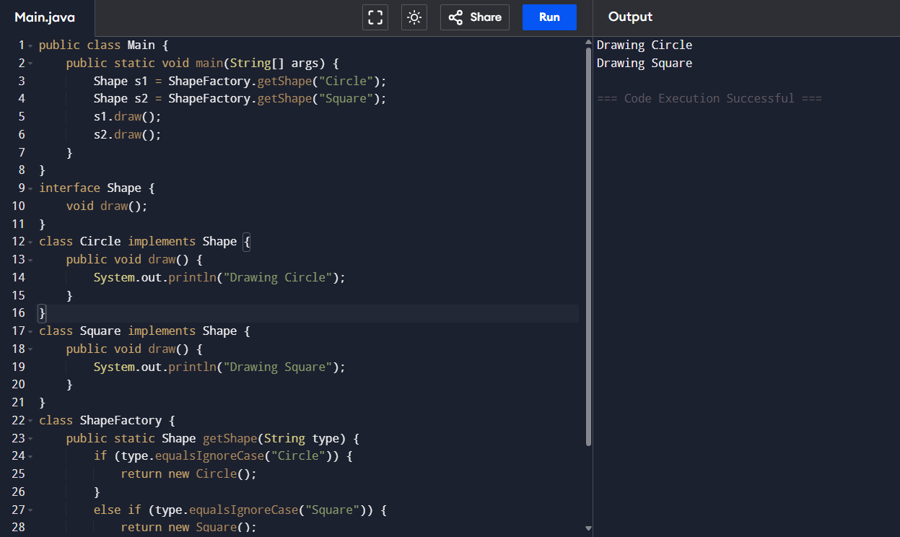

Factory – Problem 3: Runtime Decision Factory
public class Main {
public static void main(String[] args) {
Payment p1 = PaymentFactory.getPayment(500, "REGULAR", false);
Payment p2 = PaymentFactory.getPayment(700, "REGULAR", true);
Payment p3 = PaymentFactory.getPayment(3000, "REGULAR", false);
Payment p4 = PaymentFactory.getPayment(7000, "PREMIUM", false);
Payment p5 = PaymentFactory.getPayment(7000, "REGULAR", false);
p1.process();
p2.process();
p3.process();
p4.process();
p5.process();
}
}
interface Payment {
void process();
}
class UPI implements Payment {
public void process() {
System.out.println("Payment via UPI");
}
}
class Card implements Payment {
public void process() {
System.out.println("Payment via Card");
}
}
class NetBanking implements Payment {
public void process() {
System.out.println("Payment via NetBanking");
}
}
class PriorityBanking implements Payment {
public void process() {
System.out.println("Payment via Priority Banking");
}
}
class PaymentFactory {
public static Payment getPayment(double amount, String userType, boolean international) {
if (amount < 1000 && !international) {
return new UPI();
}
if (amount < 1000 && international) {
return new Card();
}
if (amount >= 1000 && amount <= 5000) {
return new Card();
}
if (amount > 5000 && userType.equalsIgnoreCase("PREMIUM")) {
return new PriorityBanking();
}
if (amount > 5000 && userType.equalsIgnoreCase("REGULAR")) {
return new NetBanking();
}
throw new IllegalArgumentException("Invalid transaction input");
}
}
Output:
Payment via UPI
Payment via Card
Payment via Card
Payment via Priority Banking
Payment via NetBanking

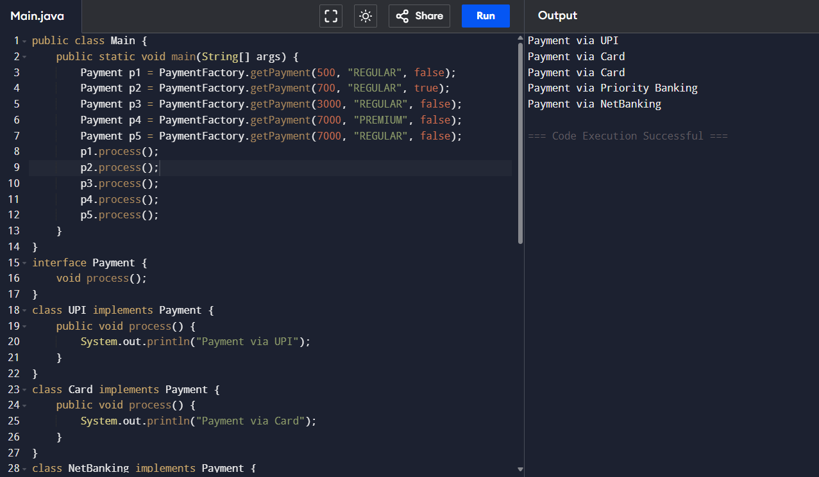

Factory – Problem 4: Abstract Factory Layer
public class Main {
public static void main(String[] args) {

DBFactory factory = DBFactoryProvider.getFactory("MYSQL");
DBConnection conn1 = factory.createConnection();
conn1.connect();

factory = DBFactoryProvider.getFactory("ORACLE");
DBConnection conn2 = factory.createConnection();
conn2.connect();
}
}

// Product interface
interface DBConnection {
void connect();
}

// MySQL implementation
class MySQLConnection implements DBConnection {
public void connect() {
System.out.println("Connected to MySQL Database");
}
}

// Oracle implementation
class OracleConnection implements DBConnection {
public void connect() {
System.out.println("Connected to Oracle Database");
}
}

// Abstract Factory
interface DBFactory {
DBConnection createConnection();
}

// Concrete Factory for MySQL
class MySQLFactory implements DBFactory {
public DBConnection createConnection() {
return new MySQLConnection();
}
}

// Concrete Factory for Oracle
class OracleFactory implements DBFactory {
public DBConnection createConnection() {
return new OracleConnection();
}
}

// Factory Provider
class DBFactoryProvider {

public static DBFactory getFactory(String type) {

if (type.equalsIgnoreCase("MYSQL")) {
return new MySQLFactory();
}
else if (type.equalsIgnoreCase("ORACLE")) {
return new OracleFactory();
}

return null;
}
}
Output:
Connected to MySQL Database
Connected to Oracle Database
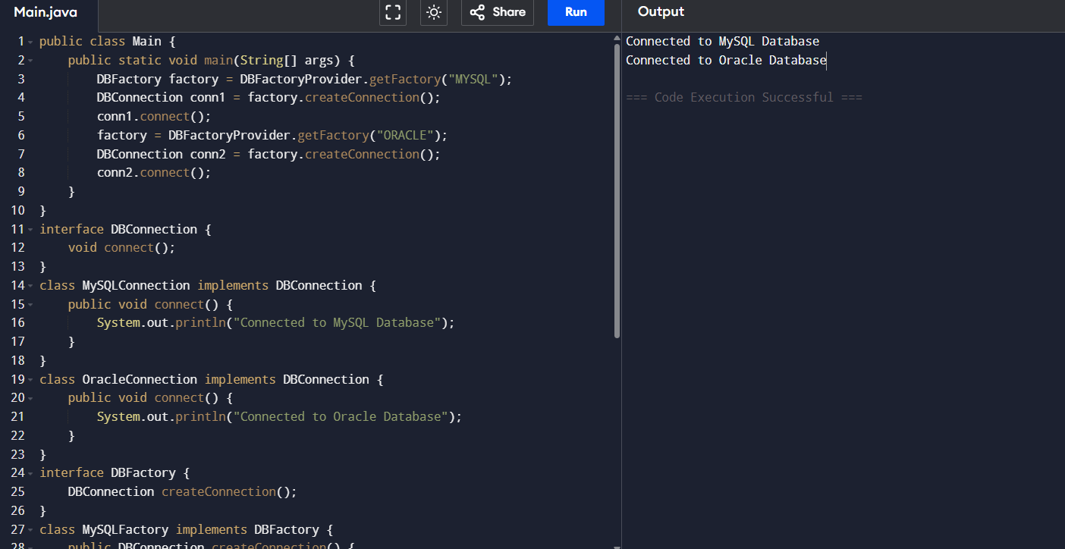

Factory – Problem 5: Domain Governance Factory
public class Main {
public static void main(String[] args) {
try {
Loan loan1 = LoanFactory.getLoan("HOME");
loan1.approve();
Loan loan2 = LoanFactory.getLoan("CAR");
loan2.approve();
Loan loan3 = LoanFactory.getLoan("CRYPTO"); // invalid
loan3.approve();
} catch (IllegalArgumentException e) {
System.out.println(e.getMessage());
}
}
}
interface Loan {
void approve();
}
class HomeLoan implements Loan {
public void approve() {
System.out.println("Home Loan Approved");
}
}
class CarLoan implements Loan {
public void approve() {
System.out.println("Car Loan Approved");
}
}
class EducationLoan implements Loan {
public void approve() {
System.out.println("Education Loan Approved");
}
}
class LoanFactory {

public static Loan getLoan(String type) {

if (type.equalsIgnoreCase("HOME"))
return new HomeLoan();

if (type.equalsIgnoreCase("CAR"))
return new CarLoan();

if (type.equalsIgnoreCase("EDUCATION"))
return new EducationLoan();

throw new IllegalArgumentException("Unauthorized Loan Type (Not RBI Approved)");
}
}
Output:
Home Loan Approved
Car Loan Approved
Unauthorized Loan Type (Not RBI Approved)
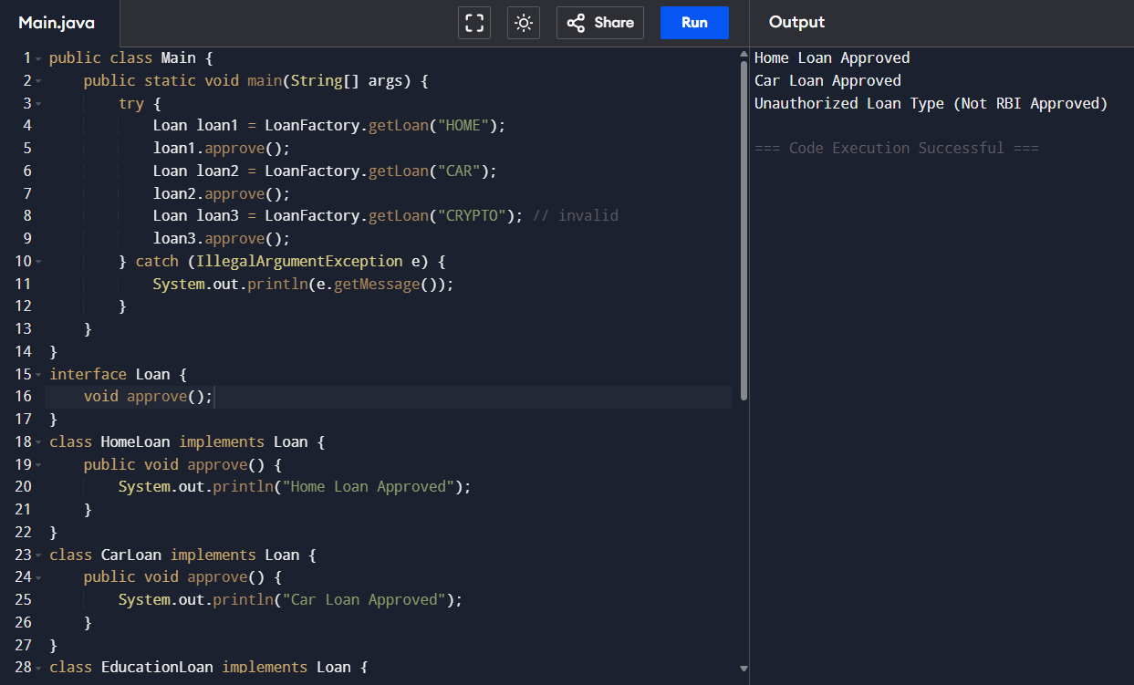

COMBINED (Record + Sealed + Factory)
Combined – Problem 1
public class Main {
public static void main(String[] args) {

Ticket t1 = TicketFactory.createTicket("MOVIE", 101, "Nandhini", 250);
Ticket t2 = TicketFactory.createTicket("TRAIN", 102, "Arun", 750);

t1.book();
t2.book();
}
}

// Record → Immutable Ticket Data
record TicketData(int ticketId, String passengerName, double price) {}

// Sealed Ticket hierarchy
sealed interface Ticket permits MovieTicket, TrainTicket, FlightTicket {
void book();
}

// Movie Ticket
final class MovieTicket implements Ticket {
private final TicketData data;

MovieTicket(TicketData data) {
this.data = data;
}

public void book() {
System.out.println("Movie Ticket Booked → " + data.passengerName() +
" | Price: " + data.price());
}
}

// Train Ticket
final class TrainTicket implements Ticket {
private final TicketData data;

TrainTicket(TicketData data) {
this.data = data;
}

public void book() {
System.out.println("Train Ticket Booked → " + data.passengerName() +
" | Price: " + data.price());
}
}

// Flight Ticket
final class FlightTicket implements Ticket {
private final TicketData data;

FlightTicket(TicketData data) {
this.data = data;
}

public void book() {
System.out.println("Flight Ticket Booked → " + data.passengerName() +
" | Price: " + data.price());
}
}

// Factory for ticket creation
class TicketFactory {

public static Ticket createTicket(String type, int id, String name, double price) {

TicketData data = new TicketData(id, name, price);

if (type.equalsIgnoreCase("MOVIE"))
return new MovieTicket(data);

if (type.equalsIgnoreCase("TRAIN"))
return new TrainTicket(data);

if (type.equalsIgnoreCase("FLIGHT"))
return new FlightTicket(data);

throw new IllegalArgumentException("Invalid Ticket Type");
}
}
Output:
Movie Ticket Booked ? Nandhini | Price: 250.0
Train Ticket Booked ? Arun | Price: 750.0
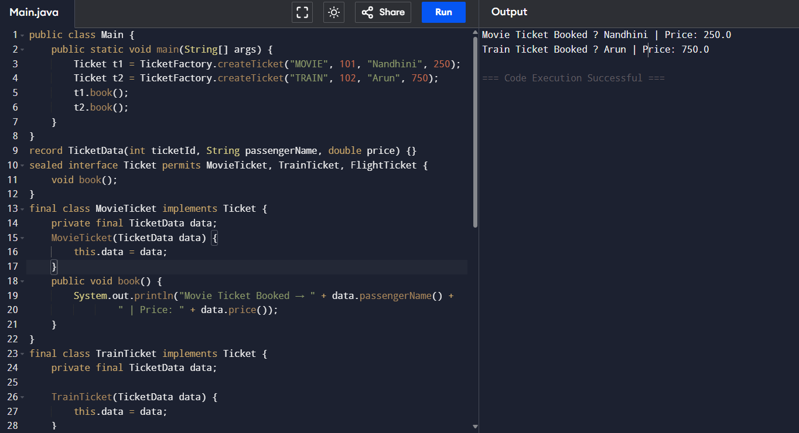

Combined – Problem 2
public class Main {
public static void main(String[] args) {
Payment p1 = PaymentFactory.createPayment("CARD", 1001, 2500);
Payment p2 = PaymentFactory.createPayment("UPI", 1002, 800);
p1.process();
p2.process();
}
}
record PaymentData(int transactionId, double amount) {}
sealed interface Payment permits CardPayment, UPIPayment, NetBankingPayment {
void process();
}
final class CardPayment implements Payment {
private final PaymentData data;
CardPayment(PaymentData data) {
this.data = data;
}
public void process() {
System.out.println("Processing Card Payment | Txn: "
+ data.transactionId() + " | Amount: " + data.amount());
}
}
final class UPIPayment implements Payment {
private final PaymentData data;
UPIPayment(PaymentData data) {
this.data = data;
}
public void process() {
System.out.println("Processing UPI Payment | Txn: "
+ data.transactionId() + " | Amount: " + data.amount());
}
}
final class NetBankingPayment implements Payment {
private final PaymentData data;
NetBankingPayment(PaymentData data) {
this.data = data;
}

public void process() {
System.out.println("Processing NetBanking Payment | Txn: "
+ data.transactionId() + " | Amount: " + data.amount());
}
}
class PaymentFactory {
public static Payment createPayment(String type, int txnId, double amount) {

PaymentData data = new PaymentData(txnId, amount);

if (type.equalsIgnoreCase("CARD"))
return new CardPayment(data);

if (type.equalsIgnoreCase("UPI"))
return new UPIPayment(data);

if (type.equalsIgnoreCase("NETBANKING"))
return new NetBankingPayment(data);

throw new IllegalArgumentException("Invalid Payment Mode");
}
}
Output:
Processing Card Payment | Txn: 1001 | Amount: 2500.0
Processing UPI Payment | Txn: 1002 | Amount: 800.0
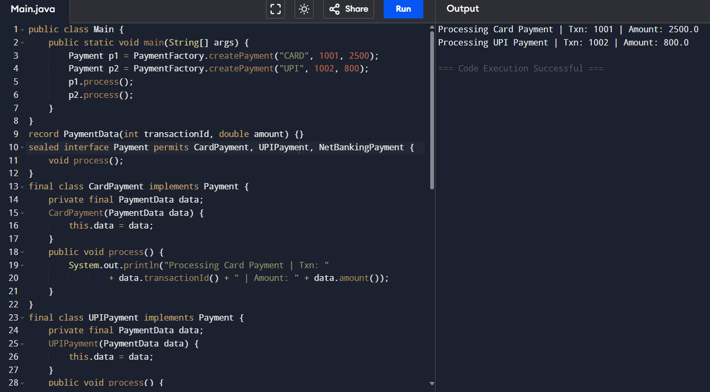

Combined – Problem 3
public class Main {
public static void main(String[] args) {

Account acc1 = AccountFactory.createAccount("SAVINGS", 101, "Nandhini", 15000);
Account acc2 = AccountFactory.createAccount("CURRENT", 102, "Arun", 50000);

acc1.showDetails();
acc2.showDetails();
}
}

// Record → Immutable Account Snapshot
record AccountSnapshot(int accountId, String holderName, double balance) {}

// Sealed hierarchy for account types
sealed interface Account permits SavingsAccount, CurrentAccount, FixedDepositAccount {
void showDetails();
}

// Savings Account
final class SavingsAccount implements Account {
private final AccountSnapshot data;

SavingsAccount(AccountSnapshot data) {
this.data = data;
}

public void showDetails() {
System.out.println("Savings Account | ID: " + data.accountId()
+ " | Holder: " + data.holderName()
+ " | Balance: " + data.balance());
}
}

// Current Account
final class CurrentAccount implements Account {
private final AccountSnapshot data;

CurrentAccount(AccountSnapshot data) {
this.data = data;
}

public void showDetails() {
System.out.println("Current Account | ID: " + data.accountId()
+ " | Holder: " + data.holderName()
+ " | Balance: " + data.balance());
}
}

// Fixed Deposit Account
final class FixedDepositAccount implements Account {
private final AccountSnapshot data;

FixedDepositAccount(AccountSnapshot data) {
this.data = data;
}

public void showDetails() {
System.out.println("Fixed Deposit Account | ID: " + data.accountId()
+ " | Holder: " + data.holderName()
+ " | Balance: " + data.balance());
}
}

// Factory → controlled creation
class AccountFactory {

public static Account createAccount(String type, int id, String name, double balance) {

AccountSnapshot snapshot = new AccountSnapshot(id, name, balance);

if (type.equalsIgnoreCase("SAVINGS"))
return new SavingsAccount(snapshot);

if (type.equalsIgnoreCase("CURRENT"))
return new CurrentAccount(snapshot);

if (type.equalsIgnoreCase("FD"))
return new FixedDepositAccount(snapshot);

throw new IllegalArgumentException("Invalid Account Type");
}
}
Output:
Processing Card Payment | Txn: 1001 | Amount: 2500.0
Processing UPI Payment | Txn: 1002 | Amount: 800.0
